## Step-03: Scaling a Deployment

* Scale the deployment to increase the number of replicas (pods)

# Scale Up the Deployment

kubectl scale --replicas=10 deployment/<Deployment-Name>

kubectl scale --replicas=10 deployment/my-first-deployment

# Verify Deployment

kubectl get deploy

# Verify ReplicaSet

kubectl get rs

# Verify Pods

kubectl get po

# Scale Down the Deployment

kubectl scale --replicas=2 deployment/my-first-deployment

kubectl get deploy

## Step-04: Expose Deployment as a Service

* Expose **Deployment** with a service (LoadBalancer Service) to access the application externally (from internet)

# Expose Deployment as a Service

kubectl expose deployment <Deployment-Name> --type=LoadBalancer --port=80 --target-port=80 --name=<Service-Name-To-Be-Created>

kubectl expose deployment my-first-deployment --type=LoadBalancer --port=80 --target-port=80 --name=my-first-deployment-service

# Get Service Info

kubectl get svc

* **Access the Application using Public IP**

http://<External-IP-from-get-service-output>

## Step-01: Updating Application version V1 to V2 using "Set Image" Option

### Update Deployment

* **Observation:** Please Check the container name in spec.container.name yaml output and make a note of it and replace in kubectl set image command

# Get Container Name from current deployment

kubectl get deployment my-first-deployment -o yaml

# Update Deployment - SHOULD WORK NOW

kubectl set image deployment/<Deployment-Name> <Container-Name>=<Container-Image> --record=true

kubectl set image deployment/my-first-deployment kubenginx=stacksimplify/kubenginx:2.0.0 --record=true

### Verify Rollout Status (Deployment Status)

* **Observation:** By default, rollout happens in a rolling update model, so no downtime.

# Verify Rollout Status

kubectl rollout status deployment/my-first-deployment

# Verify Deployment

kubectl get deploy

### Describe Deployment

* **Observation:**
  + Verify the Events and understand that Kubernetes by default do "Rolling Update" for new application releases.
  + With that said, we will not have downtime for our application.

# Descibe Deployment

kubectl describe deployment my-first-deployment

### Verify ReplicaSet

* **Observation:** New ReplicaSet will be created for new version

# Verify ReplicaSet

kubectl get rs

### Verify Pods

* **Observation:** Pod template hash label of new replicaset should be present for PODs letting us know these pods belong to new ReplicaSet.

# List Pods

kubectl get po

### Verify Rollout History of a Deployment

* **Observation:** We have the rollout history, so we can switch back to older revisions using revision history available to us.

# Check the Rollout History of a Deployment

kubectl rollout history deployment/<Deployment-Name>

kubectl rollout history deployment/my-first-deployment

### Access the Application using Public IP

* We should see Application Version:V2 whenever we access the application in browser

# Get Load Balancer IP

kubectl get svc

# Application URL

http://<External-IP-from-get-service-output>

## Step-02: Update the Application from V2 to V3 using "Edit Deployment" Option

### Edit Deployment

# Edit Deployment

kubectl edit deployment/<Deployment-Name> --record=true

kubectl edit deployment/my-first-deployment --record=true

# Change From 2.0.0

spec:

containers:

- image: stacksimplify/kubenginx:2.0.0

# Change To 3.0.0

spec:

containers:

- image: stacksimplify/kubenginx:3.0.0

### Verify Rollout Status

* **Observation:** Rollout happens in a rolling update model, so no downtime.

# Verify Rollout Status

kubectl rollout status deployment/my-first-deployment

### Verify Replicasets

* **Observation:** We should see 3 ReplicaSets now, as we have updated our application to 3rd version 3.0.0

# Verify ReplicaSet and Pods

kubectl get rs

kubectl get po

### Verify Rollout History

# Check the Rollout History of a Deployment

kubectl rollout history deployment/<Deployment-Name>

kubectl rollout history deployment/my-first-deployment

### Access the Application using Public IP

* We should see Application Version:V3 whenever we access the application in browser

# Get Load Balancer IP

kubectl get svc

# Application URL

http://<External-IP-from-get-service-output>

# **Rollback Deployment**

## Step-00: Introduction

* We can rollback a deployment in two ways.
  + Previous Version
  + Specific Version

## Step-01: Rollback a Deployment to previous version

### Check the Rollout History of a Deployment

# List Deployment Rollout History

kubectl rollout history deployment/<Deployment-Name>

kubectl rollout history deployment/my-first-deployment

we can see the three versions of deployments has been made and we check each version history by executing below commands

### Verify changes in each revision

* **Observation:** Review the "Annotations" and "Image" tags for clear understanding about changes.

# List Deployment History with revision information

kubectl rollout history deployment/my-first-deployment --revision=1

image information is the core thing

kubectl rollout history deployment/my-first-deployment --revision=2

in the annotations section we can see what command we have executed

kubectl rollout history deployment/my-first-deployment --revision=3

in the annotations section we can see what command we have executed

and pod-template-hash will be displayed

**Rollback to previous version**

* **Observation:** If we rollback, it will go back to revision-2 and its number increases to revision-4

# Undo Deployment

kubectl rollout undo deployment/my-first-deployment

# List Deployment Rollout History

kubectl rollout history deployment/my-first-deployment

we see that revision 2 will be deleted and version 4 will be created because version 2 and version 4 will be same

**Verify Deployment, Pods, ReplicaSets**

kubectl get deploy

kubectl get rs

kubectl get po

kubectl describe deploy my-first-deployment

**Access the Application using Public IP**

* We should see Application Version:V2 whenever we access the application in browser

# Get Load Balancer IP

kubectl get svc

# Application URL

http://<External-IP-from-get-service-output>

**Step-02: Rollback to specific revision**

**Check the Rollout History of a Deployment**

# List Deployment Rollout History

kubectl rollout history deployment/<Deployment-Name>

kubectl rollout history deployment/my-first-deployment

**Rollback to specific revision**

# Rollback Deployment to Specific Revision

kubectl rollout undo deployment/my-first-deployment --to-revision=3

**List Deployment History**

* **Observation:** If we rollback to revision 3, it will go back to revision-3 and its number increases to revision-5 in rollout history

# List Deployment Rollout History

kubectl rollout history deployment/my-first-deployment

**Access the Application using Public IP**

* We should see Application Version:V3 whenever we access the application in browser

# Get Load Balancer IP

kubectl get svc

# Application URL

http://<Load-Balancer-IP>

**Step-03: Rolling Restarts of Application**

* Rolling restarts will kill the existing pods and recreate new pods in a rolling fashion.

# Rolling Restarts

kubectl rollout restart deployment/<Deployment-Name>

kubectl rollout restart deployment/my-first-deployment

# Get list of Pods

kubectl get po (we can see the pods are newly created)since we have restarted

# Pause & Resume Deployments

## Step-00: Introduction

* Why do we need Pausing & Resuming Deployments?
  + If we want to make multiple changes to our Deployment, we can pause the deployment make all changes and resume it.
* We are going to update our Application Version from **V3 to V4** as part of learning "Pause and Resume Deployments"

## Step-01: Pausing & Resuming Deployments

### Check current State of Deployment & Application

# Check the Rollout History of a Deployment

kubectl rollout history deployment/my-first-deployment

(we can still access the application because we are just pausing the application)

Observation: Make a note of last version number

# Get list of ReplicaSets

kubectl get rs

Observation: Make a note of number of replicaSets present.

# Access the Application

http://<External-IP-from-get-service-output>

Observation: Make a note of application version

### Pause Deployment and Two Changes

# Pause the Deployment

kubectl rollout pause deployment/<Deployment-Name>

kubectl rollout pause deployment/my-first-deployment

# Update Deployment - Application Version from V3 to V4

kubectl set image deployment/my-first-deployment kubenginx=stacksimplify/kubenginx:4.0.0 --record=true

# Check the Rollout History of a Deployment

kubectl rollout history deployment/my-first-deployment

Observation: No new rollout should start, we should see same number of versions as we check earlier with last version number matches which we have noted earlier.

# Get list of ReplicaSets

kubectl get rs

Observation: No new replicaSet created. We should have same number of replicaSets as earlier when we took note.

# Make one more change: set limits to our container

kubectl set resources deployment/my-first-deployment -c=kubenginx --limits=cpu=20m,memory=30Mi

### Resume Deployment

# Resume the Deployment

kubectl rollout resume deployment/my-first-deployment

# Check the Rollout History of a Deployment

kubectl rollout history deployment/my-first-deployment

Observation: You should see a new version got created

# Get list of ReplicaSets

kubectl get rs

Observation: You should see new ReplicaSet.

# Get Load Balancer IP

kubectl get svc

### Access Application

# Access the Application

http://<External-IP-from-get-service-output>

Observation: You should see Application V4 version

## Step-02: Clean-Up

# Delete Deployment

kubectl delete deployment my-first-deployment

# Delete Service

kubectl delete svc my-first-deployment-service

# Get all Objects from Kubernetes default namespace

kubectl get all

Kubernetes services

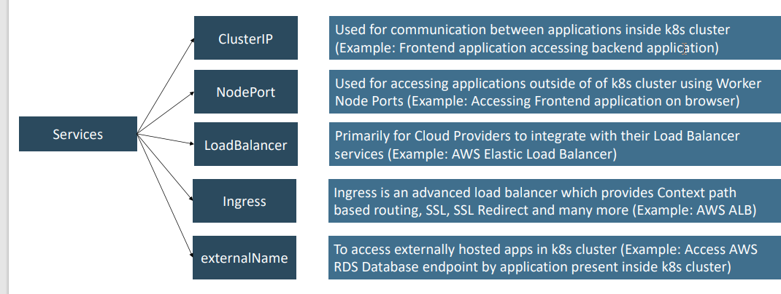

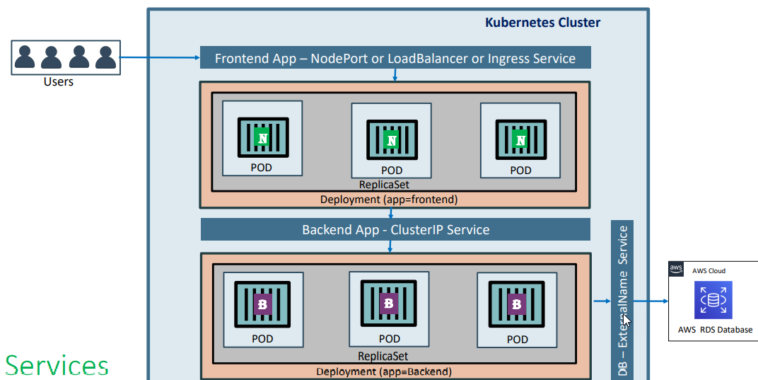

* **Service Types**
  1. ClusterIp
  2. NodePort
  3. LoadBalancer
  4. ExternalName
  5. Ingress
* We are going to look in to ClusterIP and LoadBalancer Service in this section with a detailed example.
* LoadBalancer Type is primarily for cloud providers and it will differ cloud to cloud, so we will do it accordingly (per cloud basis)
* ExternalName doesn't have Imperative commands and we need to write YAML definition for the same, so we will look in to it as and when it is required in our course.

**Step-02: ClusterIP Service - Backend Application Setup**

* Create a deployment for Backend Application (Spring Boot REST Application)
* Create a ClusterIP service for load balancing backend application.

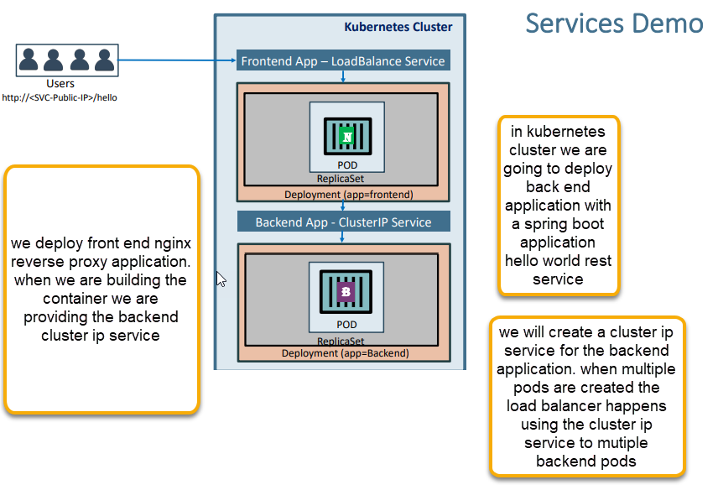

When user hits the url then request will go to the backend since we have enabled the reverse proxy application.

# Create Deployment for Backend Rest App

kubectl create deployment my-backend-rest-app --image=stacksimplify/kube-helloworld:1.0.0

kubectl get deploy

kubectl logs -f my-backend-rest-app-5784647fd6-tmt6w (to check the logs)

# Create ClusterIp Service for Backend Rest App

kubectl expose deployment my-backend-rest-app --port=8080 --target-port=8080 --name=my-backend-service

kubectl get svc

Observation: We don't need to specify "--type=ClusterIp" because default setting is to create ClusterIp Service.

* **Important Note:** If backend application port (Container Port: 8080) and Service Port (8080) are same we don't need to use **--target-port=8080** but for avoiding the confusion i have added it. Same case applies to frontend application and service.

## LoadBalancer Service - Frontend Application Setup

* We have implemented **LoadBalancer Service** multiple times so far (in pods, replicasets and deployments), even then we are going to implement one more time to get a full architectural view in relation with ClusterIp service.
* Create a deployment for Frontend Application (Nginx acting as Reverse Proxy)
* Create a LoadBalancer service for load balancing frontend application.
* **Important Note:** In Nginx reverse proxy, ensure backend service name my-backend-service is updated when you are building the frontend container. We already built it and put ready for this demo (stacksimplify/kube-frontend-nginx:1.0.0)
* **Nginx Conf File**

server {

listen 80;

server_name localhost;

location / {

# Update your backend application Kubernetes Cluster-IP Service name and port below

# proxy_pass http://<Backend-ClusterIp-Service-Name>:<Port>;

proxy_pass http://my-backend-service:8080;

}

error_page 500 502 503 504 /50x.html;

location = /50x.html {

root /usr/share/nginx/html;

}

}

* **Docker Image Location:** <https://hub.docker.com/repository/docker/stacksimplify/kube-frontend-nginx>
* **Frontend Nginx Reverse Proxy Application Source** [kube-frontend-nginx](https://github.com/stacksimplify/kubernetes-fundamentals/tree/master/00-Docker-Images/03-kube-frontend-nginx)

# Create Deployment for Frontend Nginx Proxy

kubectl create deployment my-frontend-nginx-app --image=stacksimplify/kube-frontend-nginx:1.0.0

kubectl get deploy

# Create LoadBalancer Service for Frontend Nginx Proxy

kubectl expose deployment my-frontend-nginx-app --type=LoadBalancer --port=80 --target-port=80 --name=my-frontend-service

kubectl get svc

# Get Load Balancer IP

kubectl get svc

your front end with a public ip is cretaed will be created

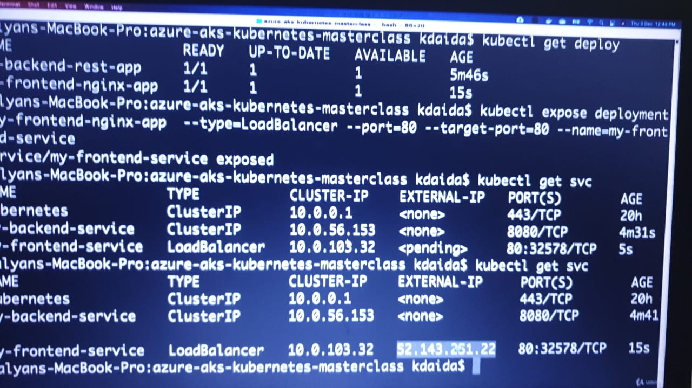

http://<External-IP-from-get-service-output>/hello

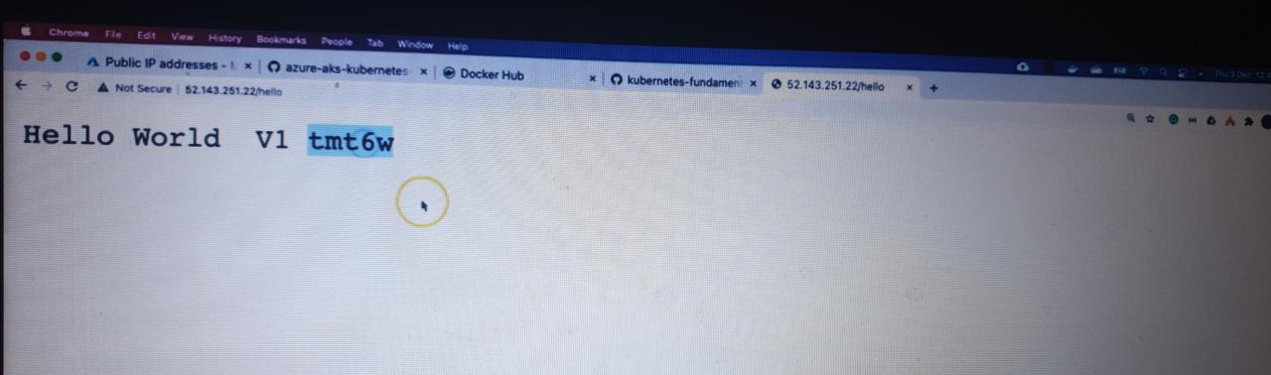

And we can see that the request it is accessing from backend public ip

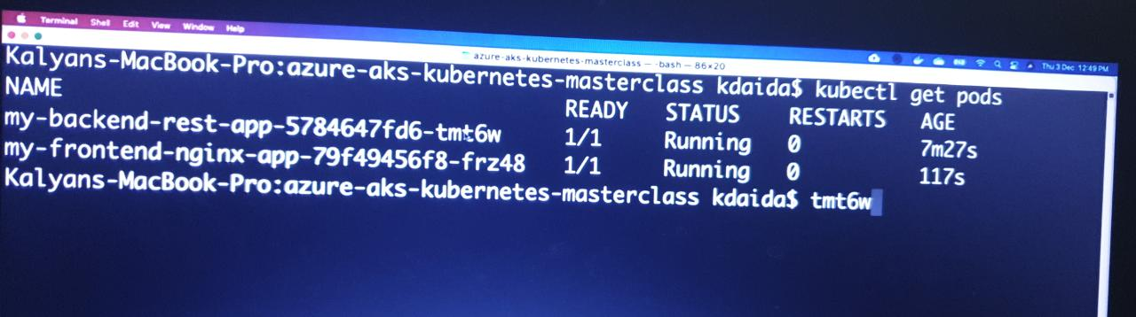

# Scale backend with 10 replicas

kubectl scale --replicas=10 deployment/my-backend-rest-app

# Test again to view the backend service Load Balancing

http://<External-IP-from-get-service-output>/hello

for imperative we don’t have replica set to mention so we used yaml

Kubernetes Fundamentals with YAML - Declarative Approach

Yaml basics

**Comments & Key Value Pairs**

* Space after colon is mandatory to differentiate key and value

# Defining simple key value pairs

name: kalyan

age: 23

city: Hyderabad

**Step-02: Dictionary / Map**

* Set of properties grouped together after an item
* Equal amount of blank space required for all the items under a dictionary

person:

name: kalyan

age: 23

city: Hyderabad

after writing the person we need to select from name to Hyderabad and we need click on tab

**Step-03: Array / Lists**

* Dash indicates an element of an array

person: # Dictionary

name: kalyan

age: 23

city: Hyderabad

hobbies: # List

- cycling

- cookines

hobbies: [cycling, cooking] # List with a differnt notation

**Step-04: Multiple Lists**

* Dash indicates an element of an array

person: # Dictionary

name: kalyan

age: 23

city: Hyderabad

hobbies: # List

- cycling

- cooking

hobbies: [cycling, cooking] # List with a differnt notation

friends: # multiple list

- name: friend1

age: 22

- name: friend2

age: 25

---(YAML document separator WE need to use ---)

## Sample Pod Tempalte for Reference

apiVersion: v1 # String

kind: Pod # String

metadata: # Dictionary

name: myapp-pod

labels: # Dictionary

app: myapp

spec:

containers: # List

- name: myapp

image: stacksimplify/kubenginx:1.0.0

ports:

- containerPort: 80

protocol: "TCP"

- containerPort: 81

protocol: "TCP"

Create Pod Definition using YAML

For metadata name, labels, namespace are the important things and metadata is nothing but information about resource additional information about pod

Spec is nothing but what exactly you are building in Kubernetes cluster and we will mention name, image and container port

**Create Simple Pod Definition using YAML**

* We are going to create a very basic pod definition
* **02-pod-definition.yml**

apiVersion: v1 # String

kind: Pod # String

metadata: # Dictionary

name: myapp-pod

labels: # Dictionary

app: myapp

spec:

containers: # List

- name: myapp

image: stacksimplify/kubenginx:1.0.0

ports:

- containerPort: 80

* **Create Pod**

# Create Pod

kubectl create -f 02-pod-definition.yml

[or]

kubectl apply -f 02-pod-definition.yml

# List Pods

kubectl get pods

**Create a LoadBalancer Service**

* **03-pod-LoadBalancer-service.yml**

apiVersion: v1

kind: Service

metadata:

name: myapp-pod-loadbalancer-service # Name of the Service

spec:

type: NodePort

selector:

# Loadbalance traffic across Pods matching this label selector traffic will goes to the container which is present inside the pod.

app: myapp

# Accept traffic sent to port 80

ports:

- name: http

port: 80 # Service Port

targetPort: 80 # Container Port

* **Create LoadBalancer Service for Pod**

# Create Service

kubectl apply -f 03-pod-LoadBalancer-service.yml

# List Service

kubectl get svc

# Access Application

http://<Load-Balancer-Service-IP>

# ReplicaSets with YAML

## Step-01: Create ReplicaSet Definition

* **replicaset-definition.yml**

apiVersion: apps/v1

kind: ReplicaSet

metadata:

name: myapp2-rs

spec:

replicas: 3 # 3 Pods should exist at all times.

selector: # Pods label should be defined in ReplicaSet label selector

matchLabels:

app: myapp2

template:

metadata:

name: myapp2-pod

labels:

app: myapp2 # Atleast 1 Pod label should match with ReplicaSet Label Selector

spec:

containers:

- name: myapp2

image: stacksimplify/kubenginx:2.0.0

ports:

- containerPort: 80

the replica set need to identify the pods it is managing. How it will manage the pods based on the match labels (selector match labels)

Myapp2-rs managing the pod whatever the label is myapp2-pod

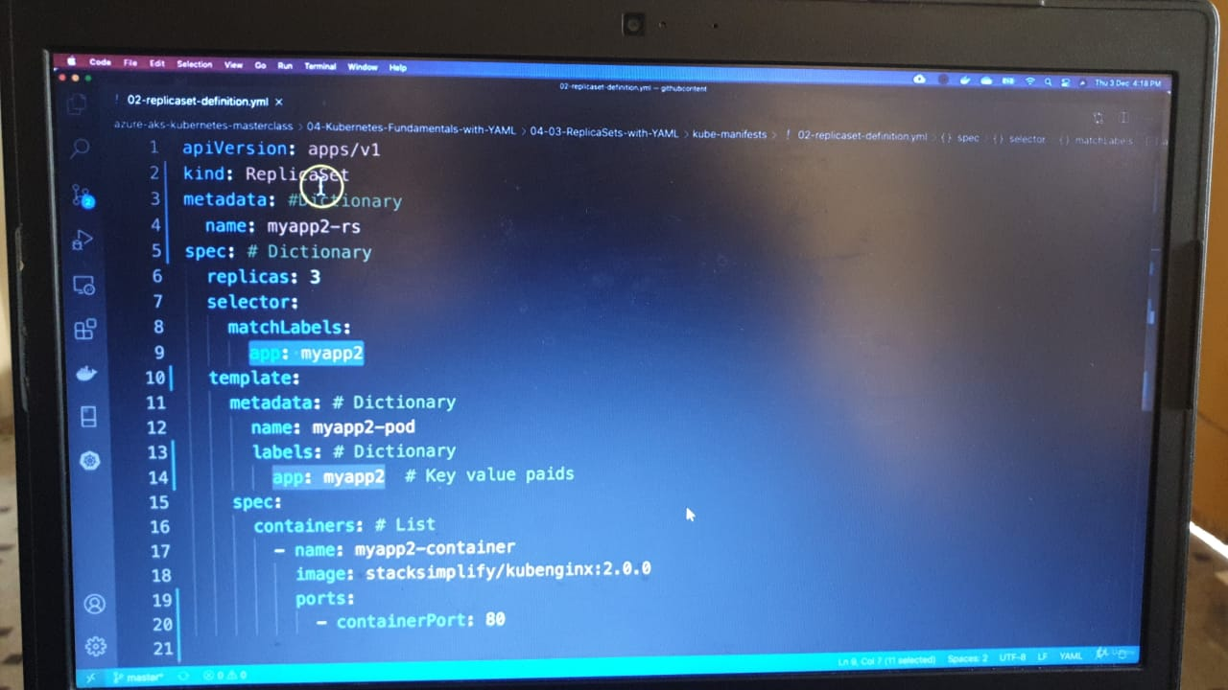

Create ReplicaSet

kubectl apply -f 02-replicaset-definition.yml

# List Replicasets

kubectl get rs

Delete a pod

ReplicaSet immediately creates the pod.

# List Pods

kubectl get pods

# Delete Pod

kubectl delete pod <Pod-Name>

## Create LoadBalancer Service for ReplicaSet

apiVersion: v1

kind: Service

metadata:

name: replicaset-loadbalancer-service

spec:

type: LoadBalancer

selector:

app: myapp2

ports:

- name: http

port: 80

targetPort: 80

load balancer will identify the pod based on the label of the pod (app: myapp2)

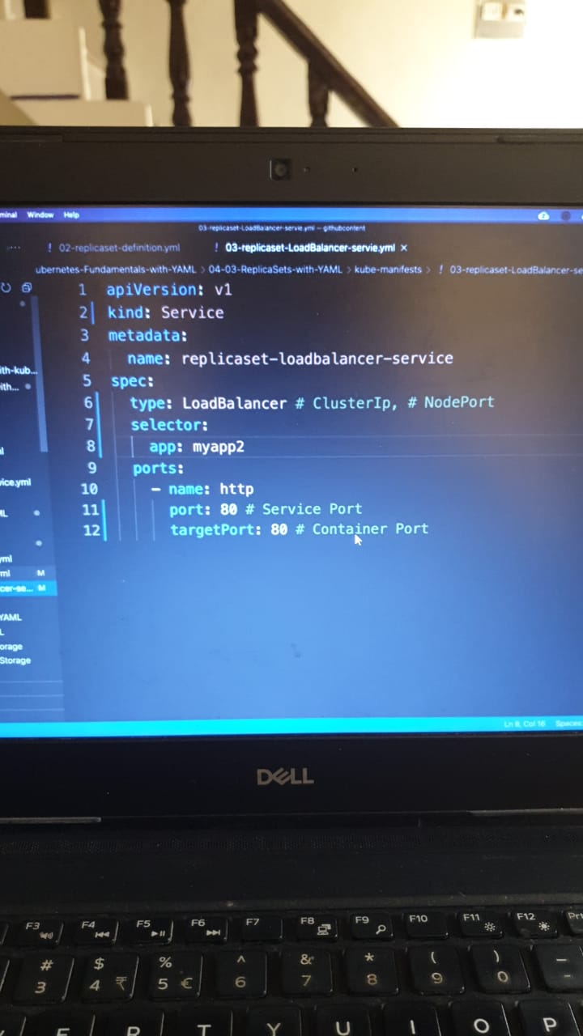

* **Create LoadBalancer Service for ReplicaSet & Test**

# Create LoadBalancer Service

kubectl apply -f 03-replicaset-LoadBalancer-servie.yml

# List LoadBalancer Service

kubectl get svc

# Access Application

http://<Load-Balancer-Service-IP>

# Deployments with YAML

## Step-01: Copy templates from ReplicaSet

* Copy templates from ReplicaSet and change the kind: Deployment
* Update Container Image version to 3.0.0
* Change all names to Deployment
* Change all labels and selectors to myapp3

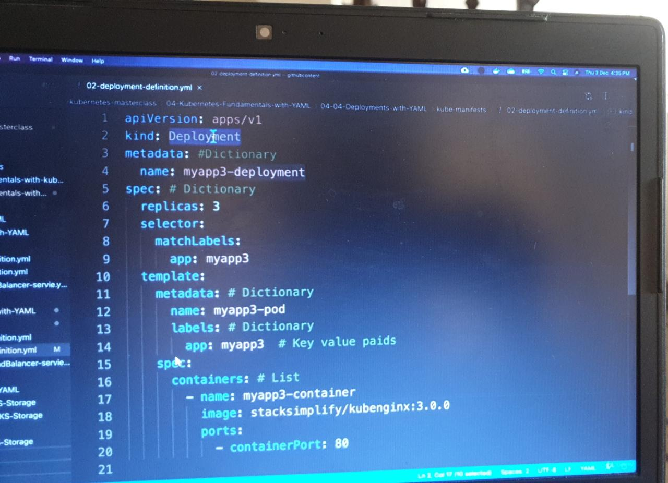

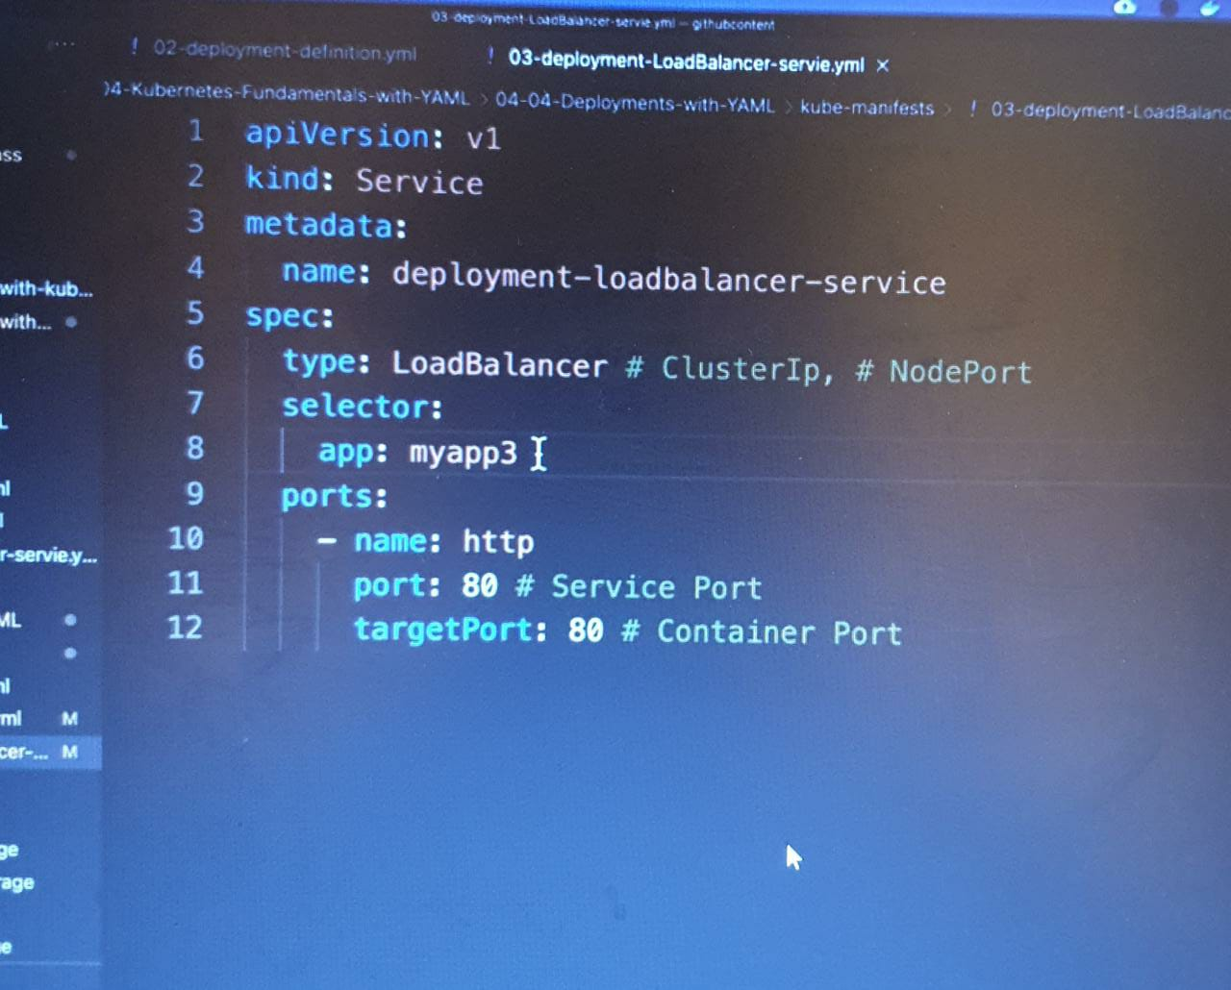

Create Deployment

kubectl apply -f 02-deployment-definition.yml

kubectl get deploy

kubectl get rs

kubectl get po

# Create LoadBalancer Service

kubectl apply -f 03-deployment-LoadBalancer-service.yml

# List Service

kubectl get svc

# Get Public IP

kubectl get nodes -o wide

# Access Application

http://<Load-Balancer-Service-IP>

# Services with YAML

## Step-01: Introduction to Services

* We are going to look in to below two services in detail with a frotnend and backend example
  + LoadBalancer Service
  + ClusterIP Service

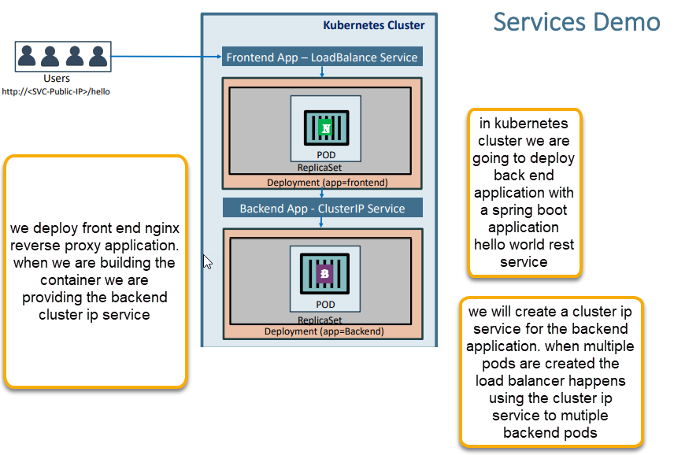

## Step-02: Create Backend Deployment & Cluster IP Service

* Write the Deployment template for backend REST application.
* Write the Cluster IP service template for backend REST application.
* **Important Notes:**
  + Name of Cluster IP service should be name: my-backend-service because same is configured in frontend nginx reverse proxy default.conf.
  + Test with different name and understand the issue we face
  + We have also discussed about in our section [03-04-Services-with-kubectl](https://github.com/stacksimplify/azure-aks-kubernetes-masterclass/tree/master/03-Kubernetes-Fundamentals-with-kubectl/03-04-Services-with-kubectl)

Back end deployment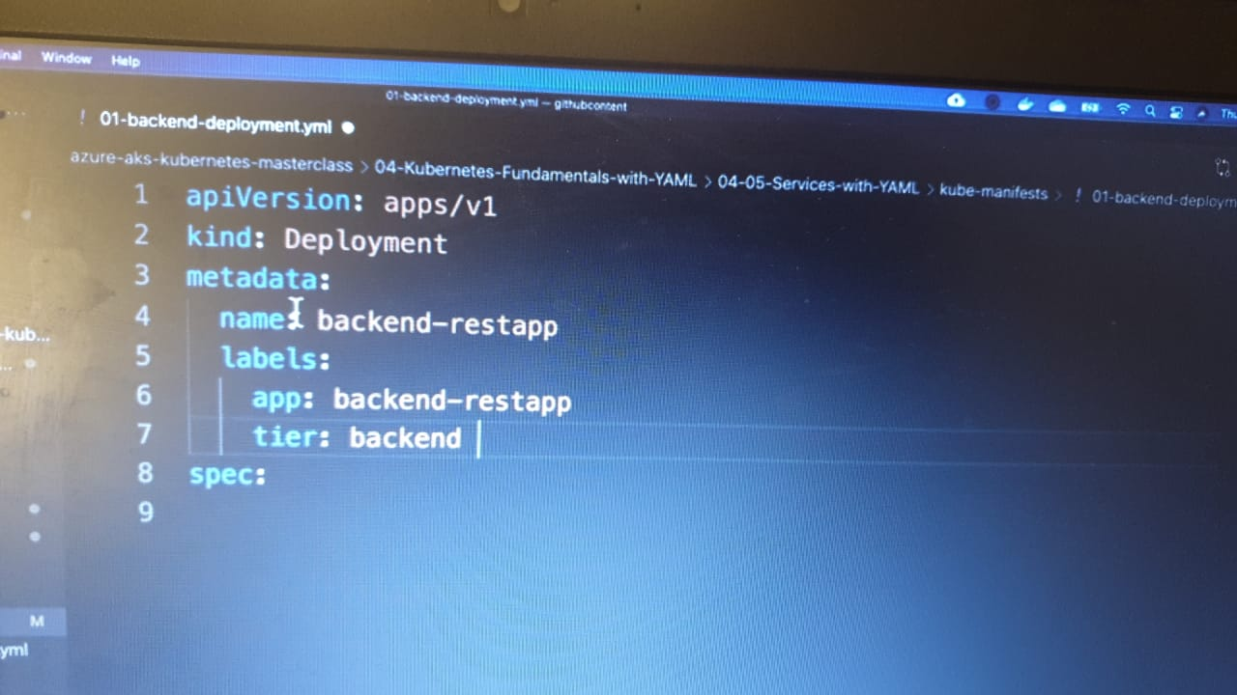

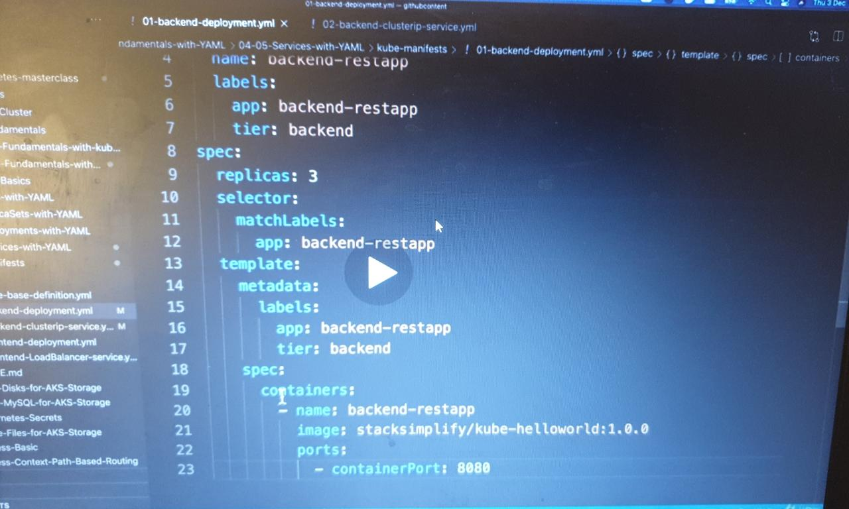 backend cluster ip deployment

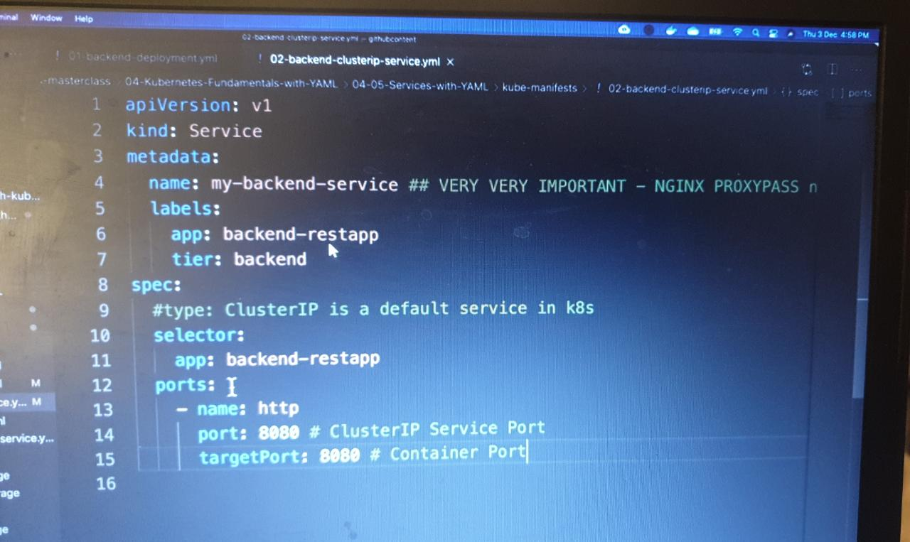

cd 04-05-Services-with-YAML/kube-manifests

kubectl get all

kubectl apply -f 01-backend-deployment.yml -f 02-backend-clusterip-service.yml

kubectl get all

kubectl get pods (

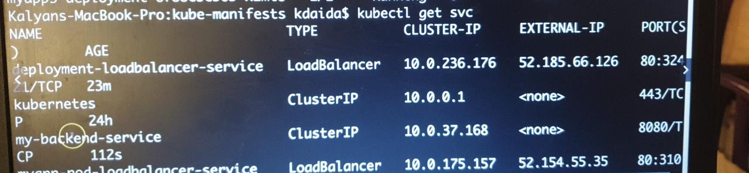

In the service we will see the external IP is NOT associated for backend service